**Prerequisites**

1. **Technology:-** Java, JDK 1.7, J2EE, Servlet, JSP, HTML, CSS, Java Script, jQuery **[Optional]**
2. **\*Database:-** MySQL 5.2.47 **[Mandatory]**
3. **\*Application server:-** Tomcat 7.0 **[Mandatory]**
4. **Development environment:-** Eclipse 4.2 (Juno) **[Optional]**
5. **Reporting tool: - Eclipse** BIRT (Business Intelligence and Reporting Tools) 3.7.2. **[Optional]**
6. **\*Operating system:-** Window7, Linux **[Mandatory]**

**Step to deploy WAR file into Tomcat application server**

Here is the step by step to follow to deploy tool in server.

1. Install JDK1.7 (Open source) **\*** in your system
2. Install MySQL Workbench v 5.2.47 (Open source) **\*** in your system
3. Install Tomcat application server (Open source) **\*** in your system
4. Download Eclipse and keep in a folder(eg. wrkspaceSandip) your system
5. Now open Eclipse and inport TapasMetrix project into wrkspaceSandip

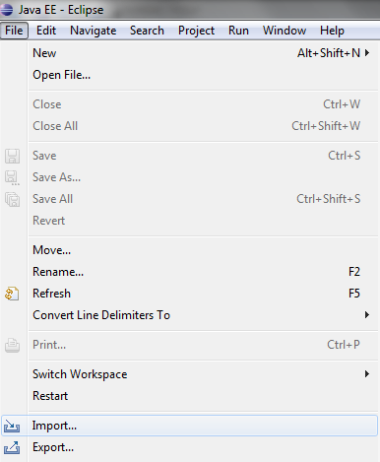

1. Clean and build this TapasMetrix Project
2. Now from eclipse Get WAR File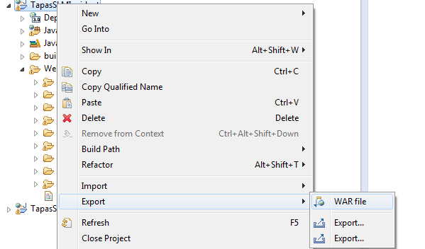
3. Now Go to Tomcat\bin\
4. Shutdown server

**Command:** \Tomcat\bin\./”shutdown.sh”

1. Copy WAR and paste it at \Tomcat 7.0\webapps\.war
2. Start the server

**Command:** \Tomcat\bin\./”startup.sh”

1. Login to Tapas Metrics Web application with your login credentials.
2. To view log or running application or server

**Command:** \Tomcat\logs\catalina.out

==========================================

I have exported database by following command.

C:\Program Files\MySQL\MySQL Server 5.6\bin>mysqldump -u root -proot cncmetrics>

D:\skrdb\cncmetrics.sql

You can import this database by following command.

C:\Program Files\MySQL\MySQL Server 5.6\bin>mysql -u username -p -h localhost cncmetrics <cncmetrics.sql